附件2

VTS服务指南-（中国）-（洋浦交管中心）(征求意见稿)

一、VHF程序

（一）分区
洋浦交管中心VTS覆盖区分为1个分区：
分区 工作频道
洋浦港管理服务区 VHF CH13
在洋浦港管理服务区内的船舶应呼叫洋浦交管中心，并必须在相应VHF频道上保持守听。

（二）VTS覆盖区
洋浦港管理服务区报告线为19°37′58.50″N/109°7′43.00″E、19°37′57.10″N/108°54′39.90″E、19°52′15.70″N/ 108°54′37.50″E、19°52′17.42″N/109°15′19.47″E四点连线.

两种特殊的线如下表示：
VTS界线
报告线（与VTS界线重合） | 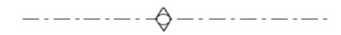

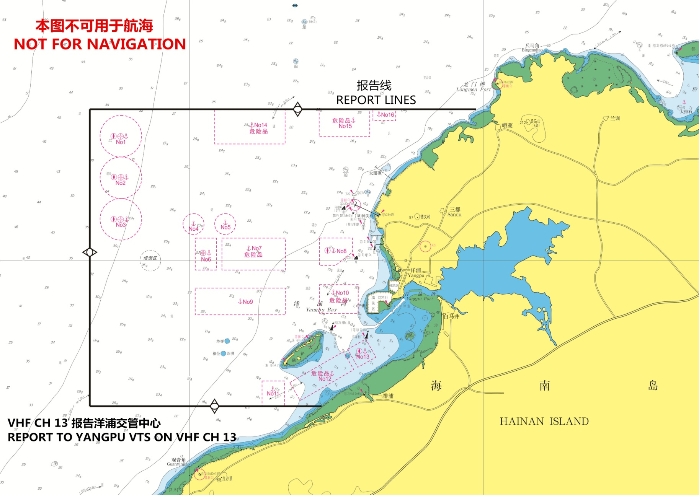

二、船舶报告

（一）适用船舶
洋浦交管中心适用于除军用船、公务船、渔船、体育运动船外的下列船舶：
1.客船、客滚船；
2.300总吨及以上的其他船舶；
3.300总吨以下自愿参加船舶报告的船舶。

（二）驶入报告
1.报告时机：通过报告线
2.报告：洋浦交管中心
3.报告方式：VHF CH13
4.报告内容：船名、呼号、位置、始发港、目的港、缺陷和限制（拖船应报告其拖带长度及被拖物名称）及VTS要求的其他信息。

（三）抵港报告
1.报告时机：船舶抵达洋浦港管理服务区内锚地
2.报告：洋浦交管中心
3.报告方式：VHF CH13
4.报告内容：船名、锚位及完成时间。
（四）进港报告
1.报告时机：船舶起锚前，抵达航道和泊位
2.报告：洋浦交管中心
3.报告方式：VHF CH13
4.报告内容：船名、动态。
（五）变化报告
1.报告时机: 船舶锚位、泊位等变化
2.报告: 洋浦交管中心
3.报告方式: VHF CH13
4.报告内容: 变化的项目。

（六）开航报告
1.报告时机：船舶离泊和驶离航道，起锚前
2.报告：洋浦交管中心
3.报告方式：VHF CH13
4.报告内容：船名、动态和下一港。

（七）事故报告
1.报告时机：船舶发生影响交通安全和环境污染事故
2.报告：洋浦交管中心
3.报告方式：VHF CH13
4.报告内容：事故细节。

（八）异常情况报告
1.报告时机：发现妨碍航行安全的异常情况
2.报告：洋浦交管中心
3.报告方式：VHF CH13
4.报告内容：船名与异常情况。

（九）活动报告
1.报告时机（应在以下行动之前报告）：
1.1检修主机、舵机、锚机、电台、锅炉以及其他影响船舶操纵性能的设备；
1.2试航、试车和测试磁罗经；
1.3航道内拖带或测速；
1.4非锚地水域以外锚泊；
1.5放艇进行救生演习；
1.6其他影响通航安全的作业。
2.报告：洋浦交管中心
3.报告方式：VHF CH13
4.报告内容：船名、船位，活动内容及其他信息。

三、引航

（一）引航报告
1.报告时机：引航员登离轮
2.报告：洋浦交管中心
3.报告方式：VHF CH13
4.报告内容：登离开船名、时间、位置、引航员姓名及被引船舶动态。

（二）强制引航船舶
外国籍船舶。

（三）引航员登离点
1. 19°48′.80N,109°04′.20E，半径0.4海里
2. 19°49′.00N,108°56′.40E，半径1海里
3. 19°45′.00N,109°07′.30E，半径0.2海里
4. 19°43′.20N,109°05′.50E，半径0.4海里
5. 19°44′.40N,109°02′.60E，半径0.4海里
6. 19°40′.80N,109°08′.80E，半径0.2海里
7. 19°50′.50N,109°08′.00E，半径0.2海里
8. 19°46′.80N,109°02′.00E，半径0.2海里
9. 19°43′.60N,109°08′.20E，半径0.2海里

四、提供的服务
（一）信息服务
（二）助航服务
（三）交通组织服务
（四）联合服务

五、获取信息途径
（一）中华人民共和国海南海事局
网站：http://www.hnmsa.gov.cn/
电话：（0898）68626004
传真：（0898）68666526
（二）洋浦交管中心
电话：（0898）36993270
传真：（0898）36980906
（三）海南省船舶引航站
电话：（0898）68651948

Vessel Traffic Services Guide
–( China ) –(YangPu VTS)
1. VHF Procedures
1.1 SECTOR:
YangPu VTS area consists of 1 sectors:
Sector Working channel
YangPu port management and service area VHF CH13
Vessels should call YangPu VTS when navigate in the appropriate VTS area and maintain a continuous listening watch on the appropriate VHF Channel.
1.2 VTS area
Management and service area of YangPu: w ater area encircled by lines connecting the following four geographical points:
(1)19°37′58.50″N 109°7′43.00″E
(2)19°37′57.10″N 108°54′39.90″E
(3)19°52′15.70″N 108°54′37.50″E
(4)19°52′17.42″N 109°15′19.47″E

The following specialist symbols are used:
Limit of VTS zone
Report lines

2. Reports
2.1 Applicability:
In addition to military ships, official ships, fishing boats and sports boats,the following ships should report to YangPu VTS when navigate in YangPu management and service area:
1. passenger ships,ro-ro passenger ship;
2. Other ships of 300 gross tonnage and above;
3.Ships under 300 gross tonnage and voluntarily using it.
2.2 Entry Report
WHEN: passing the VTS reporting line (point) and/or approaching the berth or anchorage.
TO: YangPu VTSCenter.
VIA: VHF CH13.
GIVING: report ship’s name, call sign, position(latitude and longitude or fixed position from landmark), port of departure, port of destination, defects and limitation (towing ships shall report the length of the tow and name of object being towed) and other required information.
2.3 Arrival Report
WHEN: as arriving at the YangPu anchorge.
TO: YangPu VTSCenter.
VIA: VHF CH13.
Giving: ship’s name, anchoring position, finishing time.
2.4 Berthing Report
WHEN: before heaving up anchor, arriving at channel or berth.
TO: YangPu VTS Center.
VIA: VHF CH13.
GIVING: ship’s name , status of the ship.
2.5 Deviation Report
WHEN: Ship`s achorging position, berth and other changes.
TO: YangPu VTS Center.
VIA: VHF CH13.
GIVING: situation of change.
2.6 Pre-move and Pre-departure Report
WHEN: before moving or departing channel.
TO: YangPu VTS Center.
VIA: VHF CH13.
GIVING: ship’s name, status of the ship, port of destination.
2.7 Incident report
WHEN: all vessels shall immediately report any incident impairing safety or the environment.
TO: YangPu VTS Center.
Via: VHF CH13.
Giving: full details of the incident
2.8 Observations Report
WHEN: observing any conditions that may affect the safety of navigation.
TO:YangPu VTS Center.
Via:VHF CH13.
Giving: Navigational status and any accidents and/or damage occurred during navigation.
2.9 Activities Reports
WHEN:befor carrying out any of the following operations:
- repairing main engine , boiler, windlass, steering gear and orther equipment that affects the handling performance of a ship.
- Testing main engines, ship trials or calibrating magnetic compass.
- Towing or velocity measurement in a channel .
- dropping/heaving up anchor in the outside of anchorage.
- Launching life boats for life saving\ fire drills
- other activities may afflect safe navigation.
TO: YangPu VTS Center.
Via: VHF CH13.
Giving: ship’s name, position, activity information.

3. Pilotage
3.1 Pilot Report
WHEN: pilot embarking or disembarking.
TO: YangPu VTS
VIA: VHF CH 19
GIVING: ship’s name, time, position, pilot’s name or No. and status of the ship.
3.2 Pilotage is compulsory for:
1. foreign vessels;
3.3 Pilot boarding stations (PBS)
1.19°48′.80N,109°04′.20E，Radius 0.4 nautical mile
2. 19°49′.00N,108°56′.40E，Radius1 nautical mile
3. 19°45′.00N,109°07′.30E，Radius 0.2 nautical mile
4. 19°43′.20N,109°05′.50E，Radius 0.4 nautical mile
5. 19°44′.40N,109°02′.60E，Radius 0.4 nautical mile
6. 19°40′.80N,109°08′.80E，Radius 0.2 nautical mile
7. 19°50′.50N,109°08′.00E，Radius 0.2 nautical mile
8. 19°46′.80N,109°02′.00E，Radius 0.2 nautical mile
9. 19°43′.60N,109°08′.20E，Radius 0.2 nautical mile

4. Services Offered
1. Information Service (INS);
2. Navigational Assistance Service (NAS);
3. Traffic Organization Service (TOS);
4. Information to support joint operation (on request);

5. Information Inquiry
1. Authority: HaiNan MSA
Web links: http://www.hnmsa.gov.cn/
Telepgone: +86-0898-68626004
Fax: +86-0898-68666526
2.Authority: YangPu VTS center
Telepgone: +86-0898-36993270
Fax: +86-0898-36980906
3.Authority: Port Pilot Station of Hainan Province
Telepgone: +86-0898-68651948

